Activation Function

Deep learning activation functions play a crucial role in neural networks by introducing non-linearity to the model. They enable neural networks to capture complex relationships in data. Let's explore some of the common activation functions in detail:

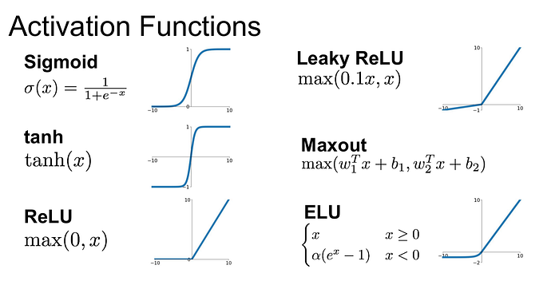

1. Sigmoid Activation Function:

- Formula: \(f(x) = \frac{1}{1 + e^{-x}}\)

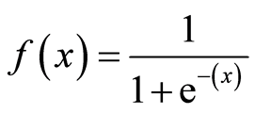

- Range: (0, 1)

- Properties:

- Smooth, differentiable, and monotonic.

- Squashes input values to a range between 0 and 1.

- Commonly used in the output layer of binary classification models.

- Drawbacks:

- Prone to vanishing gradients, especially in deep networks.

- Outputs are not zero-centered, which can slow down training in some cases.

2. Hyperbolic Tangent (Tanh) Activation Function:

- Formula: \(f(x) = \frac{e^x - e^{-x}}{e^x + e^{-x}}\)

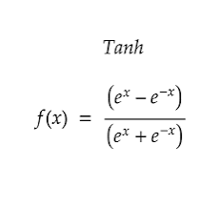

- Range: (-1, 1)

- Properties:

- Smooth, differentiable, and zero-centered (mean is close to 0).

- Squashes input values to a range between -1 and 1.

- Often used in hidden layers of neural networks.

- Drawbacks:

- Similar to the sigmoid function, it can suffer from vanishing gradients.

3. Rectified Linear Unit (ReLU) Activation Function:

- Formula: f(x) = max(0,x)

- Range: [0, ∞)

- Properties:

- Simple and computationally efficient.

- Highly effective in practice for most deep learning tasks.

- Overcomes vanishing gradient problems in many cases.

- However, it can suffer from "dying ReLU" problem (neurons stuck at zero for all inputs).

- Variations:

- Leaky ReLU: Allows a small, non-zero gradient for negative inputs to mitigate the dying ReLU problem.

- Parametric ReLU (PReLU): Learns the slope for negative inputs during training.

4. Exponential Linear Unit (ELU) Activation Function:

- Formula:

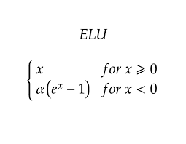

- Range: (-∞, ∞)

- Properties:

- Smooth, differentiable, and zero-centered.

- Similar to ReLU but with a differentiable transition for negative inputs.

- Helps mitigate the dying ReLU problem.

- Hyperparameter: α controls the slope of the function for negative inputs.

5. Scaled Exponential Linear Unit (SELU) Activation Function:

- Formula:

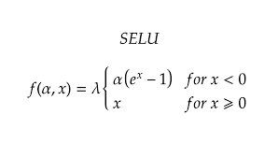

- Properties:

- Zero-centered and smooth.

- Designed to maintain mean and variance during training, potentially leading to faster convergence.

- Scaled version of ELU.

- Requires specific weight initialization to be effective.

6. Swish Activation Function:

- Formula:

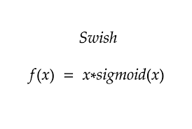

- Range: (-∞, ∞)

- Properties:

- Introduced by Google's researchers as a smooth and non-monotonic activation function.

- Empirically found to outperform ReLU in some cases.

- Controlled by a hyperparameter β, typically set to 1.

These activation functions are crucial for neural networks to introduce non-linearity and enable them to model complex relationships in data. The choice of activation function depends on the specific problem, network architecture, and empirical performance during training and validation. Experimentation is often needed to determine the most suitable activation function for a given task.

Vanishing Gradient Descent

The vanishing gradient problem is a challenge that arises during the training of deep neural networks, particularly those with many layers (deep architectures). It occurs due to the diminishing gradients as they are propagated backward through the layers during the training process. This problem can significantly slow down or hinder the convergence of neural networks. It's especially prominent when using certain activation functions like sigmoid or hyperbolic tangent (tanh). Here's why it occurs and how to address it:

Why the Vanishing Gradient Problem Occurs:

The vanishing gradient problem is primarily caused by the nature of some activation functions and the chain rule used in backpropagation, which computes gradients during training.

1. Activation Functions: Activation functions like sigmoid and tanh squash their input values into a limited range (0 to 1 for sigmoid and -1 to 1 for tanh). As you move away from the origin (either toward 0 or extreme values), the gradients of these functions become very small. Consequently, during backpropagation, gradients in earlier layers that pass through these small derivatives are scaled down, approaching zero. This means that the weights in these layers receive minimal updates, effectively slowing down learning.

2. Chain Rule: The chain rule of calculus is used to compute gradients in deep neural networks. Gradients in earlier layers depend on the gradients in later layers. If gradients in later layers are very small (due to activation functions), this leads to the multiplication of many small gradients along the backward path, causing earlier layers to have vanishing gradients.

Solutions to the Vanishing Gradient Problem:

1. Use Different Activation Functions:

- Replace sigmoid or tanh with activation functions that do not suffer as much from vanishing gradients. Rectified Linear Unit (ReLU) is a popular choice because it doesn't squash positive values and is computationally efficient.

2. Leaky ReLU and Parametric ReLU:

- Leaky ReLU allows a small, non-zero gradient for negative inputs, mitigating the vanishing gradient problem. Parametric ReLU (PReLU) takes this further by learning the slope for negative inputs during training.

3. Exponential Linear Unit (ELU):

- ELU is another activation function that overcomes the vanishing gradient issue by providing a smooth transition for negative inputs.

4. Initialization Techniques:

- Proper weight initialization methods like He initialization or Xavier initialization can help mitigate the vanishing gradient problem by ensuring that weights are initialized with suitable scales.

5. Batch Normalization:

- Batch normalization can help stabilize and speed up training by normalizing activations within each mini-batch.

6. Skip Connections and Residual Networks (ResNets):

- Skip connections allow gradients to flow more easily through the network by creating shortcuts from one layer to another. ResNets, in particular, are known for addressing the vanishing gradient problem in very deep networks.

7. Gradient Clipping:

- Limiting the gradient values during training can prevent them from becoming too small or too large, helping to stabilize training.

8. LSTM and GRU Layers:

- In recurrent neural networks (RNNs), Long Short-Term Memory (LSTM) and Gated Recurrent Unit (GRU) layers are designed to address the vanishing gradient problem in sequences.

It's important to note that the choice of activation function and other techniques to address the vanishing gradient problem may vary depending on the specific problem and architecture. Experimentation is often required to determine the most effective strategies for a given task.

Optimizer

Optimizers in deep learning are algorithms or methods that update the model's parameters (weights and biases) during training to minimize the loss function, thereby improving the model's performance. They play a crucial role in the training process. Let's explore several popular optimizers in detail, addressing each of your points:

1. Gradient Descent (GD):

- Definition: Gradient Descent is the fundamental optimization algorithm in deep learning. It iteratively adjusts model parameters in the direction of the negative gradient of the loss function to find the minimum.

- Where to Use and How to Use:

- GD can be used in various deep learning tasks, such as training neural networks for classification, regression, and more.

- To use GD, you need to compute the gradient of the loss function with respect to model parameters and update the parameters using a learning rate.

- Why Needed:

- GD is needed to minimize the loss function and make the model learn from data.

- Advantages:

- Simplicity and ease of implementation.

- Guaranteed convergence to a local minimum under certain conditions.

- Disadvantages:

- Slow convergence, especially for deep networks or poorly conditioned loss surfaces.

- Sensitive to the choice of learning rate, which can lead to oscillations or divergence.

- Limitations and Solutions:

- Limitation: Slow convergence.

- Solution: Variants like Stochastic Gradient Descent (SGD) and Mini-batch Gradient Descent are faster and often preferred.

2. Stochastic Gradient Descent (SGD):

- Definition: SGD is a variant of GD that updates model parameters using the gradient computed from a single randomly selected training example at each iteration.

- Where to Use and How to Use:

- SGD is widely used in deep learning for training large datasets.

- It is used similarly to GD but with smaller learning rates.

- Why Needed:

- SGD speeds up convergence by updating based on a single example at a time, making it computationally efficient.

- Advantages:

- Faster convergence and better scalability for large datasets.

- Adds stochasticity, which can help escape local minima.

- Disadvantages:

- Noisy updates can lead to oscillations.

- Finding a suitable learning rate schedule can be challenging.

- Limitations and Solutions:

- Limitation: Noisy updates.

- Solution: Learning rate schedules like learning rate annealing or adaptive learning rate methods.

3. Mini-batch Gradient Descent:

- Definition: Mini-batch Gradient Descent is a compromise between GD and SGD, where model parameters are updated using a small, random subset (mini-batch) of the training data at each iteration.

- Where to Use and How to Use:

- It is widely used in deep learning for training neural networks of various sizes.

- The training process is similar to GD and SGD, but you use mini-batches instead of full datasets or single examples.

- Why Needed:

- Mini-batch GD combines the advantages of GD and SGD, offering a balance between computational efficiency and convergence speed.

- Advantages:

- Faster convergence and better utilization of hardware resources (parallelism).

- Less noisy updates compared to SGD.

- Disadvantages:

- Requires careful tuning of hyperparameters, especially the mini-batch size.

- Limitations and Solutions:

- Limitation: Hyperparameter tuning.

- Solution: Cross-validation and experimentation to find the optimal mini-batch size.

4. Adam (Adaptive Moment Estimation):

- Definition: Adam is an adaptive optimization algorithm that computes adaptive learning rates for each parameter by combining information from past gradients.

- Where to Use and How to Use:

- Adam is suitable for a wide range of deep learning tasks.

- To use Adam, set hyperparameters like learning rate, decay rates, and epsilon.

- Why Needed:

- Adam adapts the learning rate based on the past gradients, speeding up convergence and making it less sensitive to learning rate choices.

- Advantages:

- Fast convergence and good performance on a variety of tasks.

- Adaptive learning rates.

- Disadvantages:

- Requires tuning of hyperparameters.

- May not always outperform simpler optimizers like SGD or Mini-batch GD.

- Limitations and Solutions:

- Limitation: Hyperparameter tuning.

- Solution: Grid search or random search for hyperparameter optimization.

5. RMSprop (Root Mean Square Propagation):

- Definition: RMSprop is an adaptive learning rate optimization algorithm that adapts learning rates individually for each parameter.

- Where to Use and How to Use:

- It is suitable for training deep neural networks, especially when Adam is not performing optimally.

- Set hyperparameters like learning rate and decay rate.

- Why Needed:

- RMSprop adapts learning rates, mitigating issues like vanishing and exploding gradients.

- Advantages:

- Robust and adaptive to different types of data.

- Effective in practice.

- Disadvantages:

- Still requires hyperparameter tuning.

- Limitations and Solutions:

- Limitation: Hyperparameter tuning.

- Solution: Hyperparameter search methods.

Each of these optimizers has its strengths and weaknesses, making them suitable for different scenarios. The choice of optimizer often depends on the specific problem, architecture, and empirical performance during training. Experimentation is essential to find the most effective optimizer for a given task.